**Transition Diagrams**

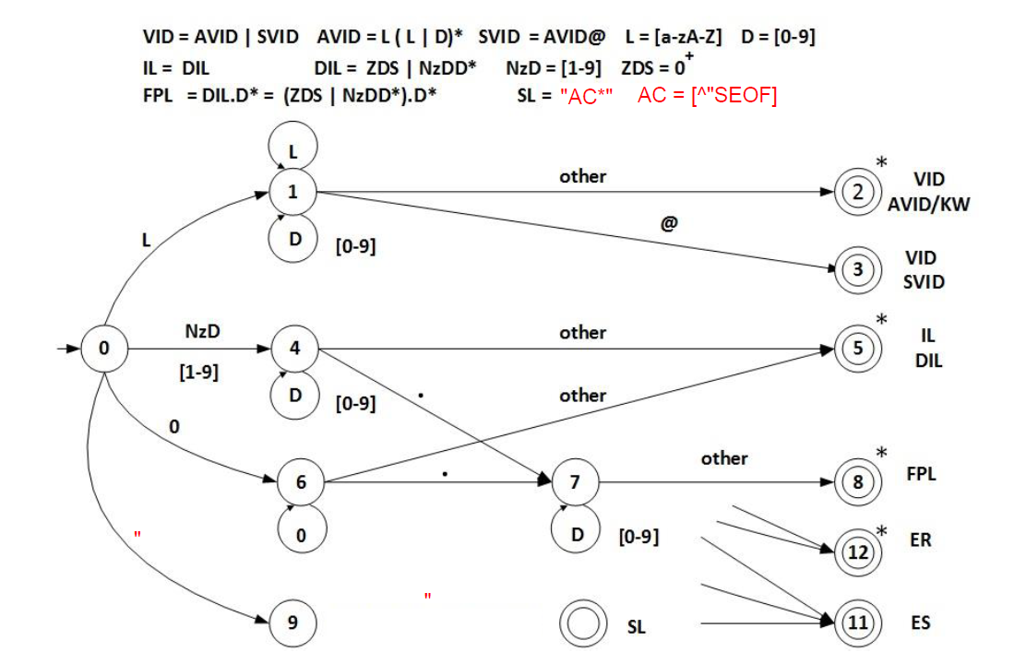

**Transition Table**

|  |  |  |  |  |  |  |  |  |  |
| --- | --- | --- | --- | --- | --- | --- | --- | --- | --- |
| Current  State | Input Symbol | | | | | | | | State Type  (NA or AS) |
| [a-zA-Z] | 0 | [1-9] | . | @ | **“** | SEOF | Other |
| 0 | 1 | 6 | 4 | ES | ES | 9 | ES | ES | NOAS |
| 1 | 1 | 1 | 1 | 2 | 3 | 2 | 2 | 2 | NOAS |
| 2 | IS | IS | IS | IS | IS | IS | IS | IS | AVID - ASWR |
| 3 | IS | IS | IS | IS | IS | IS | IS | IS | SVID – ASNR |
| 4 | ES | 4 | 4 | 7 | 5 | 5 | 5 | 5 | NOAS |
| 5 | IS | IS | IS | IS | IS | IS | IS | IS | IL/DIL – ASWR |
| 6 | ES | 6 | ES | 7 | 5 | 5 | 5 | 5 | NOAS |
| 7 | 8 | 7 | 7 | 8 | 8 | 8 | 8 | 8 | NOAS |
| 8 | IS | IS | IS | IS | IS | IS | IS | IS | FPL – ASWR |
| 9 | 9 | 9 | 9 | 9 | 9 | 10 | ES | 9 | NOAS |
| 10 | IS | IS | IS | IS | IS | IS | IS | IS | SL – ASNR |
| 11 | IS | IS | IS | IS | IS | IS | IS | IS | ES – ASNR |
| 12 | IS | IS | IS | IS | IS | IS | IS | IS | ER - ASWR |